Guidance on informing SDRC of your Horses Vaccination Programme.
Please take a photograph of page with horses name and passport number (usually towards the middle of the passport
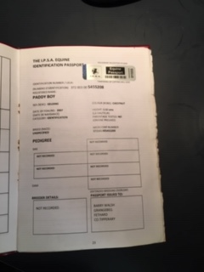
Then a picture of the vet’s identification (this may be 1 or 2 pages)
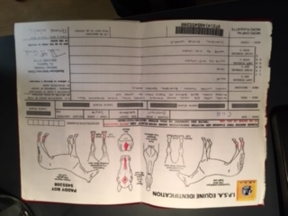
Finally a picture of the full vaccination record. It must show the initial course and follow up boosters
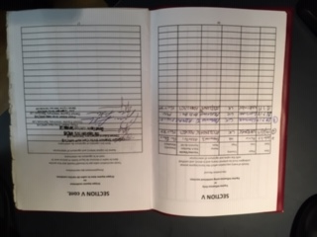
You will need to send a copy of the vaccination record each time your horse receives a booster
Please email the pictures to shillingston@hotmail.co.uk Please make sure you include your name and the name of your horse.
Thank you.

