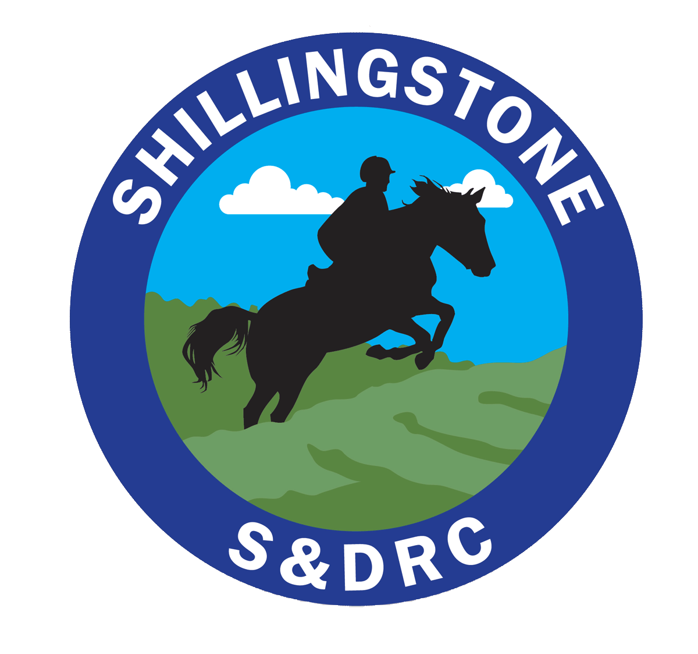

Shillingstone and District Riding Club
Non-Compliance of Health and Safety Procedure at Club events

The purpose of this document is to detail a procedure to follow by committee members in the event refusal to compile with SDRC Health and Safety policy.

All participants (riders and non riders) are asked to read the risk assessment, relevant to the riding the event they are attending prior to the event. These risk assessment are made to understand and mitigate against risk to riders, horse instructors, helpers and others. All risk assessments and SDRC are available on the website. https://www.shillingstoneanddistrictrc.co.uk/riskassessment

Procedure to follow by a committee member, in the event of non- compliance with the health and safety requirements of the event.
Any member of the SDRC Committee has the responsibility to take action in the event of non compliance which places individuals or others at risk.
First warning
Speak to the individual concerned and ask them to refrain from the action they are taking that puts others at risk.
Second warning
Ask them again and inform them that if they fail to comply with the SDRC code of conduct and requirements of the risk assessment they will be asked to leave the event and premises. Inform them that you will be reporting their behavior to BRC. A refund will not be given. This will apply to the rider or any other individual accompanying them.
Final warning
Insist that they leave and inform them that if they do not leave as soon as reasonably possible you will call the police. Complete an adverse incident form. Inform SDRC chair and Secretary
Action
Call the police
Inform the chair and secretary of the individual’s details and complete an incident for

